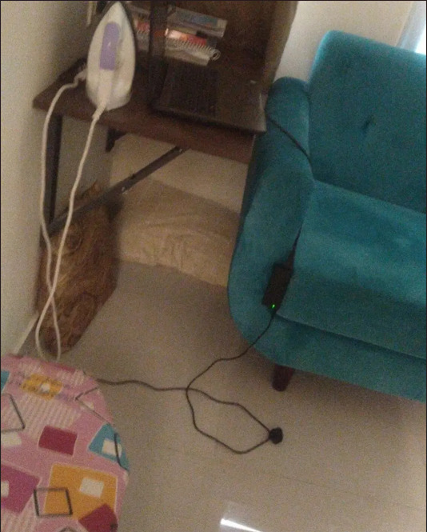

The clock is ticking at 3.43 a.m as I write this.

I have no structure in mind, but just a feeling that wants to find a way out, through words, imperfectly so.

I used to make pillow castles as a kid to sleep, I found them comforting, creative, and impenetrable by anyone, not even the demons I thought lived under my bed could reach me there.

fast forward, I still find myself making those "castles" , more like caves, to run from the demons living within me.

It is hard, to go through the full human emotional spectrum, everyday, every moment, wherein I could be the craziest knucklehead out there, or the most existential dude you'll meet.

Some days, it remains under control , the others, I go through cycles of hyperproductivity and almost catatonic states.

I hate being in those caves, and I hate this hyper productivity too.

they say normalcy is boring but oh what I wouldn't give for a shred of normalcy, but again, would that be me?

I apply the "ship of thesus " thought experiment to my life, I keep building and breaking it apart, alongside my own consciousness, to stretch it to the limits of human experience, and I wonder, if it is the same me, each time I'm reassembled .

That's the thing about most of our lives, it is a build-a-bear, whether you create pillow castles or whole empires, all of it is in a pursuit of something that'd keep you happy, make you feel warm, loved and secure.

All of it, is an expression of your desires, latching on to one idea or another in hope of fulfillment.

The thing is, there will always, be some part or aspect in your bear, that'd be missing, to be found in the bear of the kid beside you.

Would you take it from them to make yours "perfect "? if you would, I don't blame you, that's how the world is right now.

I don't, that's a choice I've made for myself. I like what I've built , as imperfect as it is, it is enough to get me through those bouts with myself, The former, and the future.

